Муниципальное бюджетное общеобразовательное учреждение
«Средняя общеобразовательная школа №125
с углубленным изучением математики»

Тема: Народы Южного Урала: Там, где встречаются культуры. The Peoples of the Southern Urals: Where Cultures Meet

Учитель английского языка
высшей квалификационной категории
Родькина Е.В.

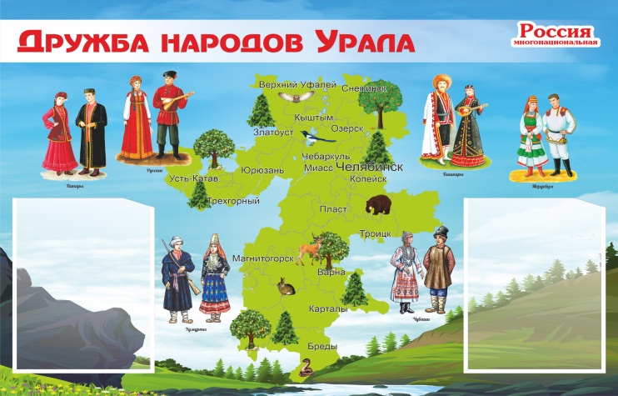

The Peoples of the Southern Urals: Where Cultures Meet
Introduction

Look at a map of Russia. You can see the Ural Mountains. They are like a big spine that divides Europe and Asia. But in the Southern Urals, this border is not just a line. It is a meeting place. For thousands of years, different peoples, cultures and traditions have met here, mixed and created something new. Today, more than 130 different ethnic groups live in the Southern Urals. Let's find out who these people are and why this region is so special.

Where Europe Meets Asia
The Southern Urals are special because they are exactly on the border between Europe and Asia. This is not just a geographical fact – it shaped the whole history of the region. Since ancient times, this area has been a "corridor" where different peoples moved and met each other. Nomadic tribes from Asian steppes met settled peoples from European plains.

Eastern traditions mixed with Western ones.
Archaeologists have found that in the Bronze Age, two big cultural groups – the Srubna people from Europe and the Andronovo people from Asia – met and influenced each other right here. Later, in the Iron Age, European weapons travelled east through this region, and Asian mirrors and jewellery travelled west. The region was a two-way street.
Even the Great Silk Road passed through parts of the Southern Urals. That is why the camel appears on the coat of arms of the Chelyabinsk Region – it symbolises trade and cultural exchange.

Who Lives in the Southern Urals Today?
So who lives in the Southern Urals today? The ethnic picture has changed many times over the centuries. The biggest change happened between the 17th and 19th centuries, when Russian settlers gradually became the majority.
Today, the ten largest ethnic groups are Russians, Bashkirs, Tatars, Kazakhs, Ukrainians, Tajiks, Germans, Uzbeks, Armenians and Azerbaijanis. But this is not the whole picture – more than 130 different peoples live in the region, and each has its own traditions, language and customs.
How do they all live together? According to researchers, the peoples of the Southern Urals have a great tradition of living in peace. Despite their differences in culture, religion and language, they stay united. They share common values – love for their homeland, tolerance, respect between generations, and mutual understanding. These values create a common spirit.

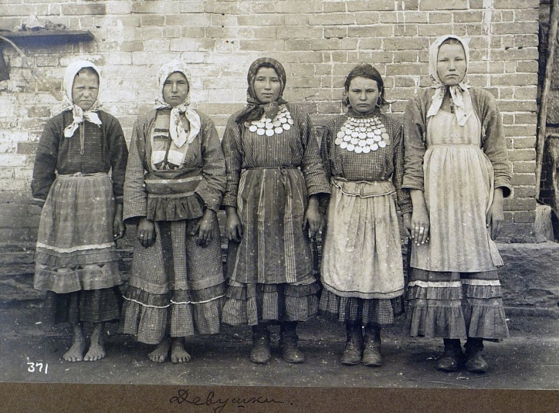
The Nagaibaks: A Very Special People
One of the most interesting groups in the Southern Urals is the Nagaibaks. They are a small indigenous people who live mainly in the Chelyabinsk Region. Their story is truly unusual.
The Nagaibaks have a mixed heritage. Their ancestors included Tatars, Bashkirs, Kalmyks, and even Arabs and Turks. These people were converted to Christianity and settled in the Ufa region. In the 1730s, when the Bashkirs rose in rebellion, the ancestors of the Nagaibaks did not join them. As a reward, they received a special status: they became Cossacks – frontier guards for the Russian Empire.
In the 1840s, the Nagaibaks were moved to the Chelyabinsk Region to protect the border from nomads. Their settlements got names that still exist today – Fershampenuaz, Paris, Kassel, Trebiya, Ostrolenka. These French-sounding names are a strange reminder of the Napoleonic Wars.
What makes the Nagaibaks truly unique is their mix of identities: they have Cossack roots, they are Orthodox Christians, and they speak the Tatar language. They are a perfect example of how cultures can mix and create something new. Nowadays, the Nagaibaks are trying hard to preserve their identity, and they have even got official status as a small indigenous people.

A Region of Tolerance
The ethnic diversity of the Southern Urals is not just history – it is something the region is proud of today. In the Chelyabinsk Region alone, over 130 ethnic groups live together. Museums, like the "Peoples and Technologies of the Urals" museum, celebrate this diversity. They show the traditions, daily life and culture of different ethnic groups.
The secret of such a multi-ethnic society is a long history of co-operation. People may have different customs and beliefs, but they have learned to live side by side. They share values and sometimes even create local traditions together. This is the real story of the Southern Urals – a story of connection, not division.
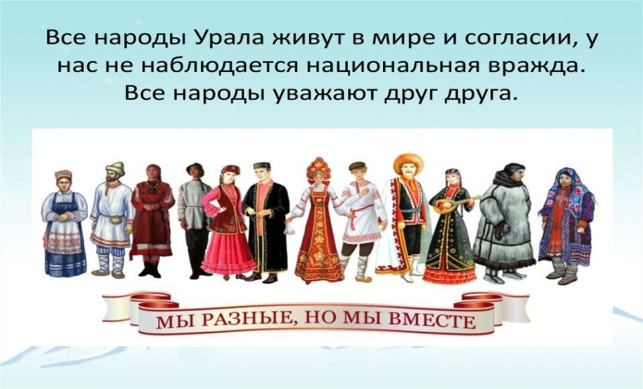

Tasks
Task 1. A Meeting Point (Speaking)
"A Cultural Festival"
You are organising a "Festival of Cultures" in the Southern Urals. Choose three ethnic groups from the article. For each group, prepare a short talk (2–3 minutes) for your classmates. Tell them:
one interesting fact about this group;
one tradition, food, or custom they are famous for;
one thing that makes them special.
You can use photos or drawings to make your talk more interesting.
Use at least 5 words from the vocabulary list in your talk.

Task 2. Who Are the Nagaibaks? (Reading Comprehension)
"Three in one"
The article says the Nagaibaks are unique because they combine three identities: Cossack roots, Orthodox Christian faith, and the Tatar language.
Read the text again and answer these questions in your own words:
How did the Nagaibaks become Cossacks? What did they do to get this status?
Why do the Nagaibaks speak Tatar if they are Orthodox Christians? (Hint: look at their ancestors.)
Why is it important for the Nagaibaks to preserve their identity? Give one reason from the text.
Write 3–5 sentences for each answer. Use at least 3 words from the vocabulary list in each answer.

Task 3. Our Community Rules (Project)
"How to live together in peace"
More than 130 ethnic groups live together in the Southern Urals. The article says that people there share values like tolerance, respect and mutual understanding.
Imagine you are making a poster for your school about "How to Live Together in Peace." On your poster, include:
Three rules for living together peacefully (for example: "Respect other people's traditions").
One activity that can help students learn about each other's cultures (for example: a food fair, a language day, or a story-telling hour).
One short slogan (a catchy phrase) about peace and friendship.
Present your poster to the class. Explain why you chose each rule and activity. Try to use at least 7 words from the vocabulary list.

